DC 2 Vapt Report

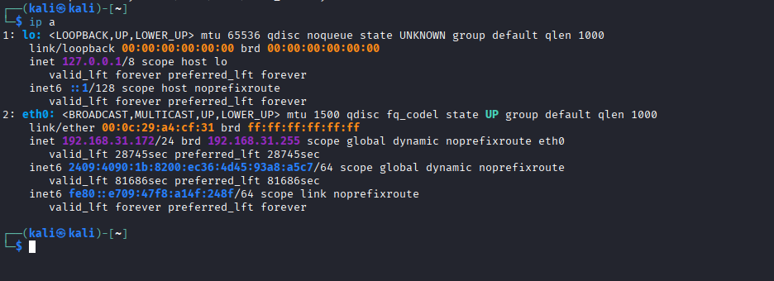
This is the ip of my machine 192.168.31.172.
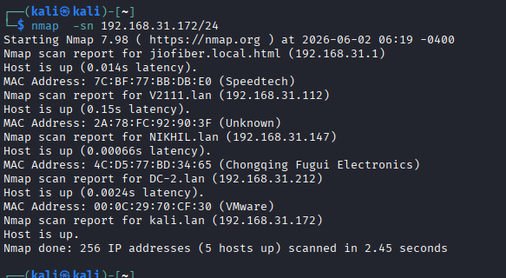
After a nmap scan we got the list of ip that are alive in the network. Through this way we have found the ip of the vulnerable machine DC 2 192.168.31.212.
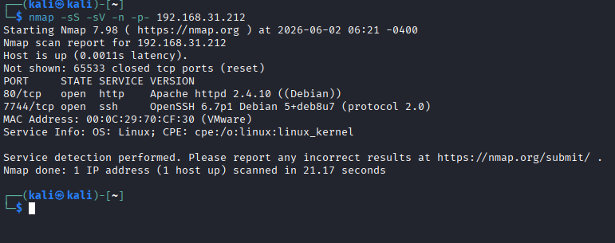
Found http service is running on port 80 in vulnerable machine.

4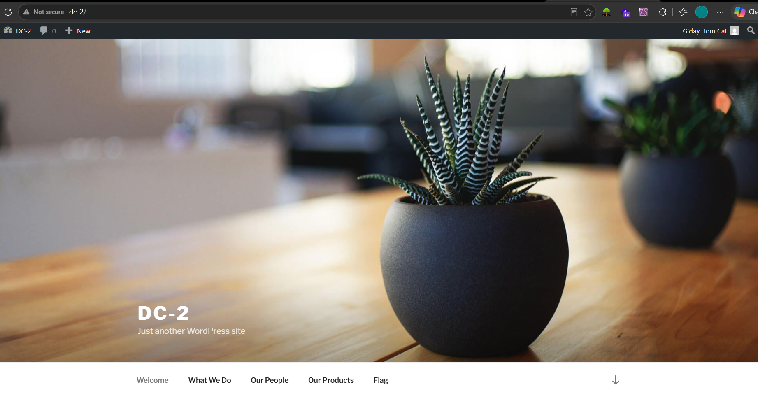
Web page running inside vulnerable machine
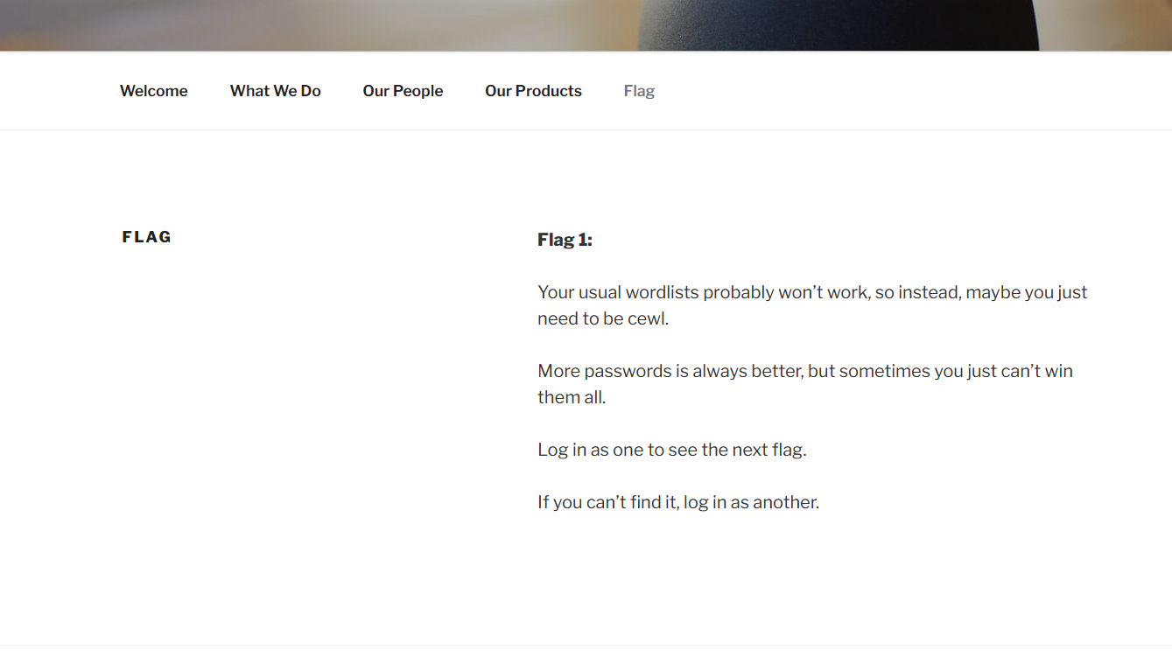
The Flag option on the webpage clearly got our attention. Let’s check what hint it has for us. So from this page, we got a really good hint to move ahead.

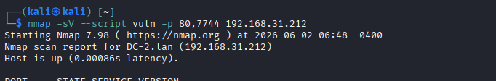
We run the nmap command to find out wether the ports are vulnerable or not.

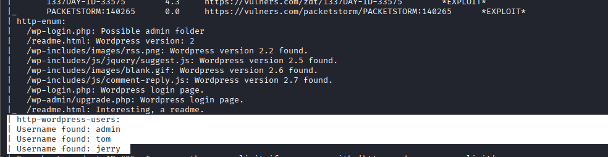
Through the enumeration we have found that this website is built in wordpress. This wordpress website is reviling the users username. Therefore, we have used cewl to build a wordlist for passwords from inside //dc-2 as shown in the image.

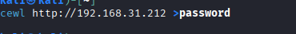
Time to fire up wpscan with our username & password list to valid user login combination.
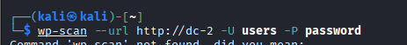

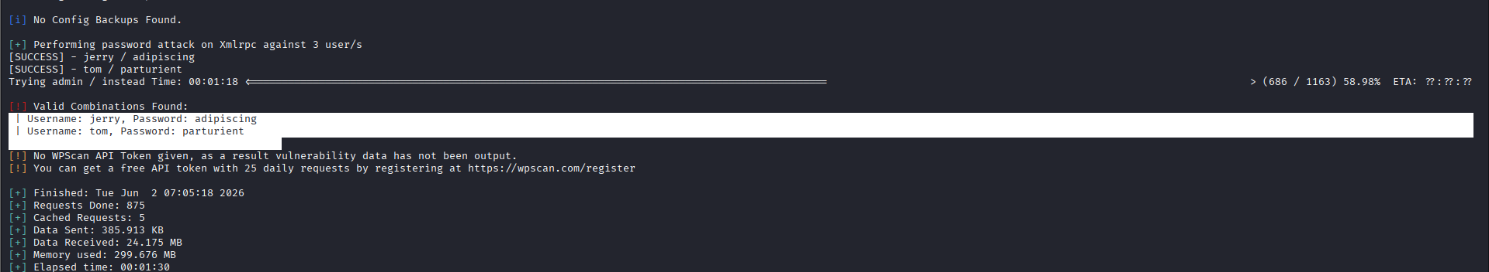
We have successfully found the password for Tom & Jerry. Let’s make good use of them.
jerry: adipiscing
tom: parturient
Further, we login to WordPress using Jerry credentials. It was holding another clue for us in Flag 2.
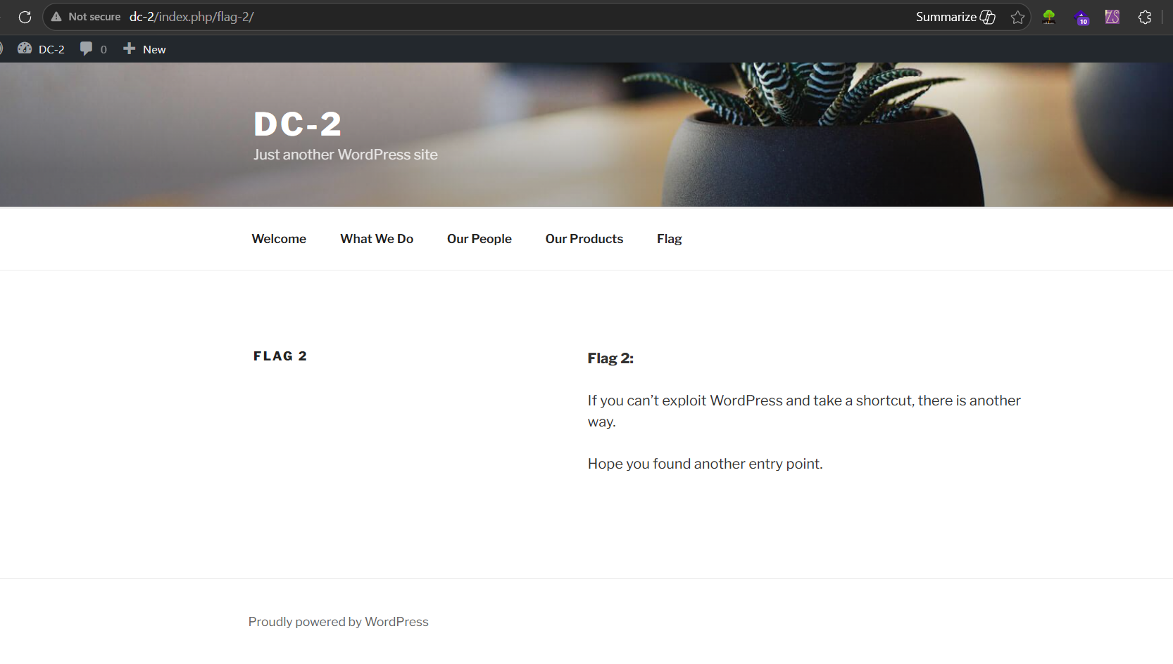
Since the clue was telling us to find another entry point to reach our final flag. Suddenly we thought to make an SSH Login running on port 77454 by using Tom credentials.
We successfully got logged in but we have a restricted shell in which some commands are not found. But few commands are available.
As you can observe that cat program is not present inside /bin and tom can run only five programs present inside /bin directory.
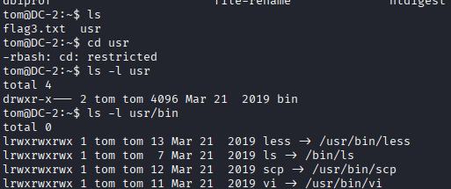
Since we had a restricted shell, we found that we can use the Vi editor. Therefore, we use Vi editor to escape the restricted shell.
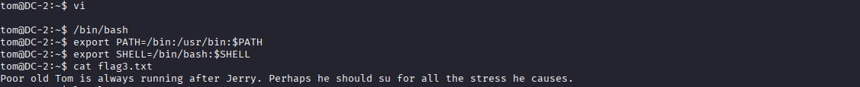
After escaping the restricted shell, we export “/bin/bash” as our SHELL environment variable and “/usr/bin” as our PATH environment variable so that we can run Linux commands properly.
export PATH=/bin:/usr/bin:$PATH
export SHELL=/bin/bash:$SHELL
According to hint, now we need to switch user from tom to jerry but we don’t have jerry’s login credential. Then checked the sudoers list and found that tom can run “/usr/bin/git” as root without a password.
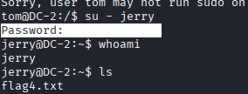
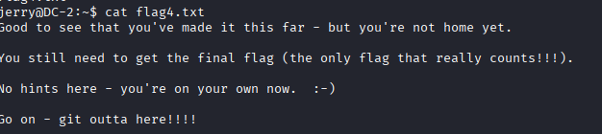

Having the root permission on git was like the cherry on the cake, because through this I can try to escalate low privilege shell to high privilege shell.

Boom!!! We got the root access, then we switch to the root directory and found our final flag.
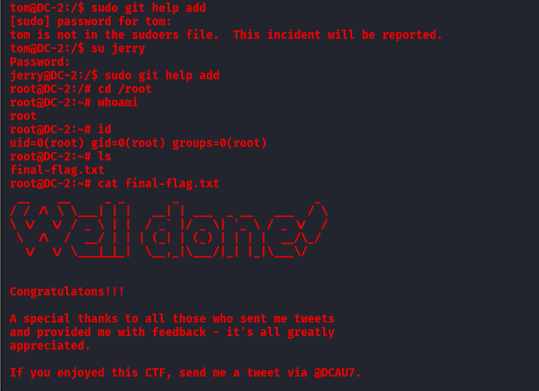
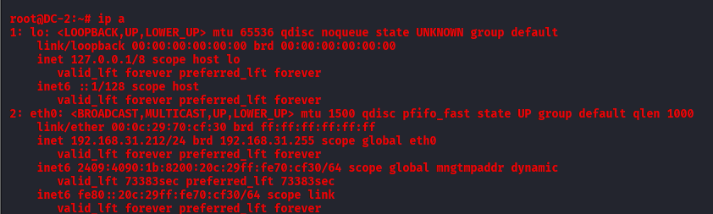
Ip of the vulnerable machine through my terminal
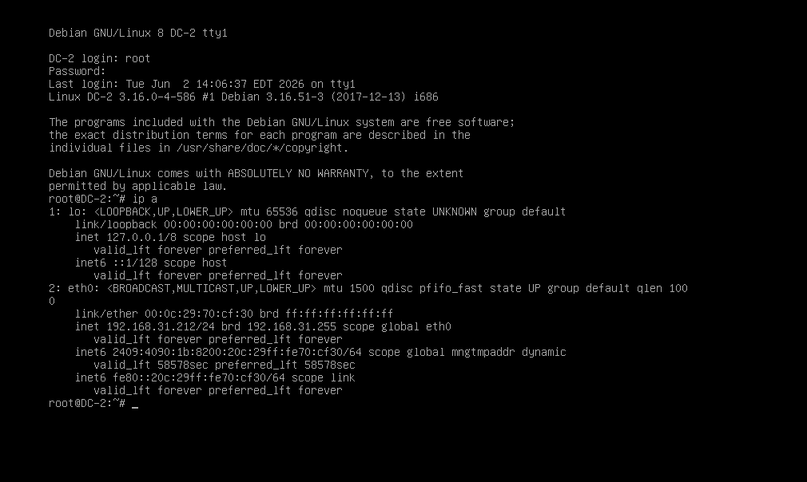

Description | The target system is running Apache HTTP Server version 2.4.10, which is an outdated and unsupported release.
Vulnerability name | Outdated Apache HTTP Server (Version 2.4.10)
Port | 80
Service name | apache httpd
Version | 2.4.10
Severity | Critical
CVE ID | CVE-2017-3167
Remediation | - Upgrade Apache HTTP Server to the latest supported version.  - Apply all vendor security patches.  - Disable unnecessary modules.  - Update OpenSSL and related dependencies.  - Perform regular vulnerability assessments.

